2.1 Graphs
Think of a graph informally as a diagram of dots, called vertices, connected by lines or curves, called edges. The edges of a graph may have arrows on them; in this case the graph is called a directed graph. A graph without arrows on the edges is called an undirected graph.
The degree of a vertex is the number of times an edge touches it. NOT the number of edges connected to it.
Example 1: A college registrar would like to schedule the following courses in as few time slots as possible: Physics, Computer Science, Chemistry, Calculus, Discrete Math, Biology, and Psychology. However, from previous experience, the following pairs of classes always have students in common, so they can't be scheduled in the same time slot:
Physics and Computer Science, Physics and Chemistry, Calculus and Chemistry, Calculus and Physics, Calculus and Computer Science, Calculus and Discrete Math, Calculus and Biology, Discrete Math and Computer Science, Discrete Math and Biology, Psychology and Biology, Psychology and Chemistry
What is the fewest number of time slots needed to schedule all these classes without conflict?
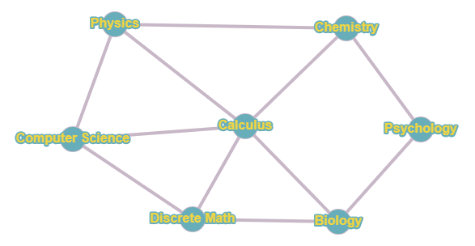
A
B
B
C
C
B
A
First, let's talk about how I made this graph!
Step 1: Make a vertex for element of your problem. (In this case, each class.) It DOES NOT matter where you place the vertices on your graph. I recommend giving yourself some space between the vertices so your graph is not too crowded. Also, if there is an element with lots of interactions in your problem, it will be easiest if its towards the center of your graph. (Since Calculus shows up so many times in our list, I put it in the middle. This isn't required, it just makes things easier.)
Step 2: Go through the list in your problem. For each pair of elements that have an interaction, connect them with an edge. (In this problem, if two classes have a time conflict, we connect them with an edge.)
Now we need to use this graph to answer the question: What's the fewest number of time slots needed to avoid conflict? This process is called graph coloring. A coloring for a graph is an assignment of different values (colors) to each vertex such that no two vertices of the same color share an edge.
Step 1 of graph coloring: Starting at any vertex, assign it a number or letter (or color if you want). In this problem, I started with Calculus and assigned it to group A.
Step 2 of graph coloring: Now move on to the next vertex. If it's connected to a vertex that's already in a group, you cannot place the vertex in that group. So you have to make a new group. (In this problem, we move on to Computer Science. It's connected to Calculus, so it cannot be in Group A, so I put it in Group B.
Step 3 of graph coloring: Repeat Step 3 until all your vertices are labelled.
Here's a breakdown of how this problem proceeded.
I moved on to Physics. Since it's connected to Calculus and Computer Science, it cannot be in Group A or B, so I created Group C for Physics.
Next we look at Discrete Math. It's connected to Computer Science and Calculus, so it cannot be in Groups A or B. However, it is NOT connected to Physics, so it's fine for us to put it in Group C. (Keep in mind we do not WANT to create new groups. We're looking for the fewest number of groups needed.)
Moving on to Chemistry, it's connected to Calculus and Physics, so it cannot be in Groups A or C, so we put it in Group B. The same thing happens with Biology.
Finally, we get to Psychology. It is only connected to elements of Group B, so we can put it in Group A or C. It doesn't matter which, so we'll just say group A.
So our final answer: The fewest number of time slots needed is 3. (A, B and C).
NOTE! The way I drew my graph, none of the edges intersected. It is perfectly fine if the edges cross each other or are curved instead of straight lines. The idea is just to draw the graph as clearly as possible, as that makes a graph easier to use.
We call a graph planar if it can be written down without any edges crossing each other. The famous Four Color Theorem states that any planar graph can be colored with, at most, four colors.
Example 2: Several departments around campus have wireless access points (WAPs), but problems arise if two WAPs within 200 feet of each other are operating on the same frequency. Suppose the departments with WAPs are situated as follows.
Department | Is within 200 feet of departments
Math | Physics, Psychology, Chemistry, Sociology
Sociology | History, English, Economics, Math, Chemistry, Psychology
Physics | Math, Chemistry
Psychology | Math, Chemistry, Sociology, Economics
History | Sociology, English
English | Economics, Sociology, History
Economics | English, Sociology, Psychology
Chemistry | Math, Psychology, Sociology, Physics

What is the fewest number of frequencies needed?
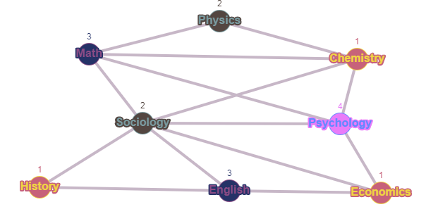
We followed the same steps as example 1. And our answer is 4 frequencies are needed.
DEFINITIONS!!!
The indegree of a vertex is the number of edges coming into the vertex.
The outdegree of a vertex is the number of edges coming out of the vertex.
Example: For the above graph, list each vertex's indegree and outdegree.
 | Indegree | Outdegree
a | 1 | 2
b | 1 | 1
c | 2 | 3
d | 1 | 1
e | 2 | 0

A quick explanation of our answer. For the indegree of a vertex, simply count the number of arrows pointing INTO that vertex. So for a, there is one arrow pointing at a, so it has an indegree of 1. For the outdegree of a vertex, simply count the number of arrows pointing OUT of that vertex. For a, there are two arrows leaving a, so its outdegree is 2.
Binary Search Tree
One use of graphs are binary search trees. The rules for constructing a binary search tree are as follows: Start with an item (chosen arbitrarily) at the top of the tree. This is the root node of the tree. The root has (at most) two edges touching it, one going down to the right, and one going down to the left. These are the children of the root node. If fact, every node can have up to two children. The only condition is that the right child must come after its parent in alphabetical (or numerical) order, and the left child and its descendants must come before its parent.
This is an example of a binary search tree. x is the parent node. l is the left child and r is the right child.
Example: Construct a binary search tree for the following words: macchiato, poset, phat, complexify, jazzed, sheafify, clueless.
We create the tree using the words in the order they're given to us in the problem, which means we start with macchiato. (For this example, I'm going to show you the tree step-by-step. However, on a quiz/test/final, you only need to give the final product, not a list of separate trees.)

Then we move to the next word on the list. "poset". Since poset is after macchiato alphabetically, we put poset as the right child of macchiato.
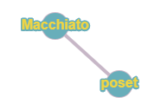
Next is phat. To figure out where it gets placed, we ALWAYS start at our base node and work our way from there. So phat is AFTER macchiato, so we go to the right. Then it is BEFORE poset alphabetically, so we put it to the left of poset.
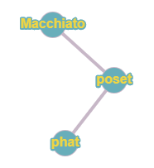

We repeat this process until we finish the list.
Next is complexify, which is BEFORE macchiato, so it goes to the left of it.
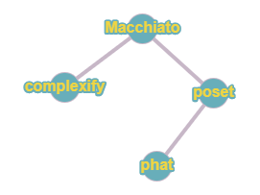
Next is jazzed, which is BEFORE macchiato, so we go left of it. Then AFTER complexify, so we go to the right.
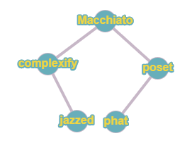
Next is sheafify. Alphabetically, this is AFTER macchiato and AFTER poset, so it's to the right of poset.
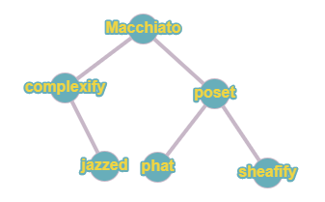
Lastly, we get to clueless. It is BEFORE macchiato and BEFORE complexify. So it's to the left of complexify.
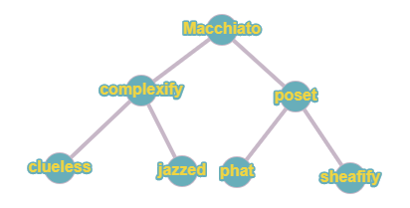
And that is our binary search tree. (Like I mentioned at the beginning of the example, this final tree is our answer. That's what you'd give as the answer to the question. The middle trees are the individual steps.)
HOMEWORK #1a,b, 2-6, 15, 17, 19, 24-28

